 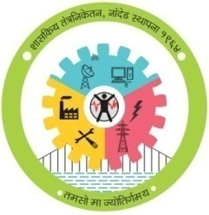

**GOVERNMENT POLYTECHNIC, NANDED**

**MICRO PROJECT**

**Academic year: 2019-20**

**TITLE OF THE PROJECT**

**Case study for online water management system.**

**Program: Information Tech. Program code: IT 4 I**

**Course: SEN Course code: 22413**

**Name of Guide:-K.P.POPLE**



**MAHARASHTRA STATE**

**BOARD OF TECHNICAL EDUCATION**

**Certificate**

This is to certify that name **Harsh, Amaan, Hifaz and Vishal** of **4th** Semester of Diploma in **INFORMATION TECTNOLOGY** of Institute, GOVERNMENT POLYTECHNIC has completed the **Micro Project satisfactorily** in Subject -**SEN(22413)** for the academic year **2019**- **2020** as prescribed in the curriculum.

Place: **Nanded**

Date:

**Subject Teacher Head of the Department Principal**

**K.P.POPLE Mr.S.N.Dhole Dr.G.V.Garje**

**WEEKLY PROGRESS REPORT**

**TITLE OF THE MICRO PROJECT:- Case study for online water management system.**

|  |  |  |  |
| --- | --- | --- | --- |
| **WEEK** | **ACTIVITY PERFORMED** | **SIGN OF GUIDE** | **DATE** |
| **1ST** | **Discussion and finalization of Topic** |  | **13/11/19** |
| **2ND** | **Preparation and submission of Abstract** |  | **20/11/19** |
| **3RD** | **Literature Review** |  |  |
| **4TH** | **Collection of Data** |  | **23/12/19** |
| **5TH** | **Discussion and Outline of Content** |  | **30/12/19** |
| **6TH** | **Formulation of Content** |  |  |
| **7TH** | **Editing and 1st Proof Reading of Content** |  |  |
| **8TH** | **Editing and 2nd Proof Reading of Content** |  |  |
| **9TH** | **Compilation of Report and Presentation** |  | **11/3/20** |
| **10TH** | **Seminar** |  | **16/3/20** |
| **11TH** | **Viva-voce** |  |  |
| **12TH** | **Final submission of Micro project** |  | **16/3/20** |

**Sign of the student Sign of the faculty**

**K.P.POPLE**

**ANEEXURE II**

**Evaluation Sheet for the Micro Project**

**Academic Year: 2019-2020 Name of the Faculty: K.P.POPLE**

**Course: SEN Course code:22413 Semester: IV**

**Title of the project: Case study for online water management system.**

**Cos addressed by Micro Project:**

A:Select suitable software process model for software development.

B:Prepare software requirement specification.

C:Use softwa

D:

**Major learning outcomes achieved by students by doing the project**

1. **Practical outcome:**
2. Deliver presentation (seminar) effectively.
3. **Unit outcomes in Cognitive domain:**
4. Prepare the points for computer presentation.
5. Make seminar presentation.
6. **Outcomes in Affective domain:**
7. Function as team member.
8. Follow Ethics.
9. Make proper use of computer and Internet

**Comments/suggestions about team work /leadership/inter-personal communication (if any)**

|  |  |  |  |  |
| --- | --- | --- | --- | --- |
| **Roll No** | **Student Name** | **Marks out of 4 for performance in group activity**  **(D5 Col.8)** | **Marks out of 2for performance in oral/ presentation**  **(D5 Col.9)** | **Total out of 06** |
| **945** | **Harsh santosh Zanwar** |  |  |  |
| **948** | **Amaan Khan Pathan** |  |  |  |
| **949** | **MD Hifaz ali Khan** |  |  |  |
| **956** | **Vishal vaijenath nilwarn** |  |  |  |

**(Signature of Faculty)**

**K.P.POPLE**

**GROUP DETAILS**

|  |  |  |
| --- | --- | --- |
| **Roll No.** | **Name** | **Enrollment No.** |
| 945 | Harsh Santosh Zanwar | 1800200119 |
| 948 | Amaan Khan Pathan | 1815660149 |
| 949 | MD Hifaz Ali Khan | 1815660141 |
| 953 | Vishal vaijenath Nilwarn | 1900200225 |

**INDEX**

|  |  |  |
| --- | --- | --- |
| **Sr No.** | **Content** | **Page No.** |
| 1 | Introduction | 1 |
| 2 | Identify Problem Statement | 2-3 |
| 3 | Perform Feasiblity analysis | 4-5 |
| 4 | Identify application specific requirements by following RE steps | 6-11 |
| 5 | External interface requirement | 12-14 |
| 6 | Test case | 15-17 |
| 7 | Design view | 18-22 |
| 8 | Conclusion | 23 |
| 9 | Reference | 24 |

**Introduction**

Case studies are a powerful and flexible empirical method. They are used primarily for exploratory investigations, both prospectively and retrospectively, that attempt to understand and explain phenomenon or construct a theory. They are generally observational or descriptive in nature, though they can be relational as well. They can also be used in the validation of research results. Due to this dexterity, they have become popular in software engineering and are frequently used in papers to understand, to explain or to demonstrate the capabilities of a new technique, method, tool, process, technology or organizational structure. Unfortunately, they are usually not used to their full potential, and often not used correctly. The aim of this full-day tutorial was to teach software engineering researchers and professionals how to effectively design, conduct, evaluate and read case studies. A case study is an empirical method. By this we mean a defined, scientific, method for posing research questions, collecting data, analyzing the data, and presenting the results. Each of these steps is planned from the outset of the study and do not come about through serendipity.

* **Identify Problem Statement**
* To design a web page to promote the business of purified water cans.
* To make online base platform in order to enhance the business and get that new customers for water supply plant.
* To generate a database for customer and their requirements in order to fulfill the customers requirement with available plant capacity
* **Concept**

Mr.Shriram pawar is currently owner of water purification plant. The water plant name is Shree water Suppliers .He

Started this business in 2018.

This plant is situated in HUDCO,new Nanded Maharashtra.

All the machinery in this plant are supplied by currently in the initial years they plant in having 500+ customers mainly the customer are looking for purified water bottles (cold,normal).We as a team aman,hifaz,harsh and vishal dicided to meet them and explain about the concept of online and website system.

For this mr.pawar is satisfied with the concept and thy will help us to make this task possible.

* **Expectation of owner**

The website should be easy to use and handle by the customers.

All the inquiries should be directly forwarded to main databse and should be easy to handle

They want to use the website as an advertising platform.

* **Expected outcome**

As modernization and availability of smart phones and internet we expect more people will attract to our website

Plant owner will have a good database which he can give offers to regular customers.

* **Future Scope**

We will make this website to an android app with owner

By which people can use this more easily

We can increase the product range as well

We will connect the different water plant owners and we will make a network of customers

* **Perform Feasiblity analysis**
* **Fisiblity analysis** :- is the process of confirming that a strategy,plan or design is possible and make sense.fisiblity study is study usually done by engineers,that establishes whether conditions are right to implement a particular project.
* **Project description**

Our aim is to design a web page to promote and expand the business of purified water bottles. This project is website development to promote water cans/services in internet and increase online sales of water bottle through encouraging customer to visit the website and make online payments and bargains.

We want to make this web page a online base platform in order to enhance the business and get new customers for water supply plants.

* **Describe possible solutions**

To provide as much as possible services and to fulfill all requirements of customer.

* This project can be undertaken by the implementation of two possible solutions

1. **Web page.**
2. **Stand alone.**

Each of the solution is carefully analyzed ,and necessary information required for making the final dicision is available for the management team and owner.

* **Project feasibility**

In future our project will be feasible financially and technically. because as modernization and availability of smartphones and internet we expect more people will attract to our website .

This would be very beneficial for plant owner because it will be easy to maintain database and he will have a option of providing offers to customer.

* **Propose the most feasible solution**

This phase include the most economical reasonable and technically feasible solution which lets the owner to gain best possible benefit.

* **Conclusion**

This project purpose is to develop a sophisticated and original design of the website that will contribute to online water supply system,attract the target customers attention,and be cost effective.

* **Identify application specific requirements by following RE steps**
* Requirements
* The website should be easy to use and handle by customers.
* All the enquires should be directly forwarded to main databse and should be easy to handle.
* They want to us this website as an advertising platform.
* Delivery should be on time
* Customers data and their bills should be accurate and correct.
* Customers data and their details should not be breaked.
* Analysis

After getting all requirements of users and anaysing them,we understood that the website needs following changes -:

* To make our website simple and easy for users, we made a simle front page for the customers so that there should not be any problem to customrs for placing order
* Our website also need very less details of account creation for the customers.
* As some customers want to use our website for their advertisement of their business,we will provide platform for advertisement on our website with effective cost.
* We will prvide quick access to users for one time delivery.
* We will manage our website and databse accurately so that there should not be any error possibility.
* After perfectly organizing our website on the above requirements we will provide accurate website.
* **Functional Requirements**

Functional requirements defines a function of a system or its component,where a function is described as a specification of behavior between outputs and inputs.

**Functional requirements are as following:-**

* Our website has a menue bar which will display user various options like about our website,my cart,my orders,rating of app etc.
* We can deliver 100 no. of bottles at a time for customers.
* Our website provide login option to user as well as admin option for developers.
* There is customer service option for customers if customer have any complain or doubt,so he or she can contact and interact with our servicers.
* **Non fuctional requirement**

Non functional requirement is a requirement that specifies criteria that can be used to judge the operation of a system,rather than specific behavior.

**Non fuctional requirements are as following:-**

* In our website there is bumper offers on special festivals for customers.
* Our system cover large area for the supply of water bottles.
* Our website should be buffered less and with less advertisement.
* We have also provided rating option to our website ,

By which customers can review our system or management.

* **Steps involved in Re-engineering:**

1. Inventory Analysis.
2. Document Reconstruction.
3. Reverse Engineering.
4. Code Reconstruction.
5. Data Reconstruction.
6. Forward Engineering.

* **Re-engineering Cost Factors:**
* The quality of the software to be re-engineered.
* The tool support available for re-engineering.
* The extent of the required data conversion.
* The availability of expert staff for re-engineering.
* **Advantages of Re-engineering:**
* **Reduced Risk:**

As the software is already existing, the risk is less as compared to new software development. Development problems, staffing problems and specification problems are the lots of problems which may arise in new software development.

* **Reduced Cost:**

The cost of re-engineering is less than the costs of developing new software.

* **Prepare SRS**

SRS stands for software/system requirement specification. SRS is a special kind of document which contains user requirements for a system which states properties and constraints that must be satisfied by a software system.

**Following are six requirements stated by heninger , which SRS documents should follow:**

1. SRS document should specify external system behaviour.
2. SRS document should specify implementation constraints.
3. It should be easily changeable if any changes occur.
4. It should act as a reference tool for maintaining the system.
5. SRS document record forethough about the lifecycle of the system i.e predicts changes.
6. It must include acceptable response to undesired event.

* **PURPOSE:**-

The SRS defines external interference performance and software system attributes requirement of water supplier. This document is intended for the following group of people.

1. Customer can get water bottles by just ordering online on our website by sitting at home.
2. Management of the water supply system.
3. Documentation for entire project.
4. Testers.

* **SCOPE:-**

1. This document applies to water management system. This software facilitates the user to order water bottles online any where in our city. This software provides various transaction options like:- google pay, net banking, PAYTM etc.
2. It also allows the administrator to fix the tariffs and rules as and when required.
3. The software takes an easy input – username , mobile no., address, for login purpose.
4. The output that comprise of an interactive display that lets the user select the desirable function that he wants to perform.

**THE OVER ALL DESCRIPTION:-**

* ProductPerspective:
* This software allows the user stoorder the water
* bottles remotely through our website without any aid of human.
* This software also allows the users to order different types of bottles as per their wish.
* Some of its hardware components are : transport system, water plants, purified water bottles, bore water system.
* Product functions :-
* language selection- after the user has logged in the display provides him with a list of languages from which he can select any one in order to interact with the machine throughout that session.
* Login-Our website provide login optionto users as well as Admin login to owner.which will maintain a proper databse and efficiency increases
* Menue bar-Our website provide a proper menue bar which will display user various options like-about our website description,my cart,my orders,rate this website etc.
* Help centre-we also provide a help centre for customer so that if there is any problem customer can contact to our help centre.
* account maintainance:
* our software provides security to the accounts of the users.
* The amount to be deducted should be automatically displayed in the database.
* **BILLING:-**

Any transaction shall be recorded in the database and message should be sent to the user about the bill.

* **CANCELLING:-**

The customers can cancel their order just by clicking on the cancel button, but the cancellation should be done before 10mins after order. Otherwise order cannot be cancelled. For example: if a customer decides that he wants less no. of bottles but we deliver more bottles as per his earlier wish, so he can cancel some bottles.

* **CONSTRAINTS: (CONDITIONS)**

1. After 10 minutes of order customer cannot cancel the order.
2. At a time we can give maximum 100 bottles to a single customer.
3. Shipping charges will be applied in the bill.
4. If customer damages our plant bottles then customer has to pay for it.

* **SYSTEMFEATURES:-**

1. Our website provide a proper menu bar which
2. will display uses various options like-about our website discription, my cart,my orders,rate this app etc.
3. We can deliver 100 no of bottels at a time for customers.
4. Our website provide login option to user well as admin option for developers.
5. There is a customer service option for customers ,if customer have any complain so he or she can interact with our service**s.**

* **External interface requirement:-**
* User interface Requirements

The interface provided to the user should be a vey user friendly one and it should provide an optional interactive help for each of the service listed.the interface provided is

A menue driven one and the following screens will be provided:

1. A login screen is provided in the beginning for entering the required username/password.
2. An unsuccessful login leads to reattempt(maximum three) screen for again entering the same information.
3. In case of administrator ,a screen will be shown having options to reboot system,shut down system,disable any service.
4. After the login, a screen with a number of option is then shown o user.it contains all the options along with the brief description to enable the user to understand the functioning and select the proper option.
5. A screen will be provide to check the location of where the water bottles are dliverd and how much time required for complte delivery.

* Sequencing Information:-

The information about the users and their account should be entered into the database prior to any of the transactions and the backup be maintained for all account information.

* Error handling/response to abnormal situations:-

If any of the above validation/sequencing flow does not hold true, appropriate error message will be prompted to the user for doing the needful.

* **Test case**

|  |  |  |  |  |  |
| --- | --- | --- | --- | --- | --- |
| Test case name | Test case discription | steps | step discription | Test data | Expected result |
| Tc_wp_01  Login verification | This test case is to verify user login | Step1  Step2 | Enter valid username  Enter valid password | Username:- ex,abc@wp  Password:-ex,wpadmin@45 | Login successful |
| Tc_wp_02  Login verification | This test case is to verify invalid user login | Step1  Step2 | Enter invalid username  Enter valid password | Username:- ex,abc@ap  Password:-ex,wpadmin@23 | Login unsuccessful |
| TC_WP_04 Payment option | This test case is to check the payment option | Step1  Step2 | Cash on delivery  Online payment | bill recipt  bill recipt | available(pa-y ment by cash)  available(pa-  yment by net banking) |
| TC_WP_05  Bill generation | This test case is for displaying bill to user | Step1 | This step include displaying bill to user | total no of bottles:- Amount:- | Bill |

* **Design view**

**Use case diagram**

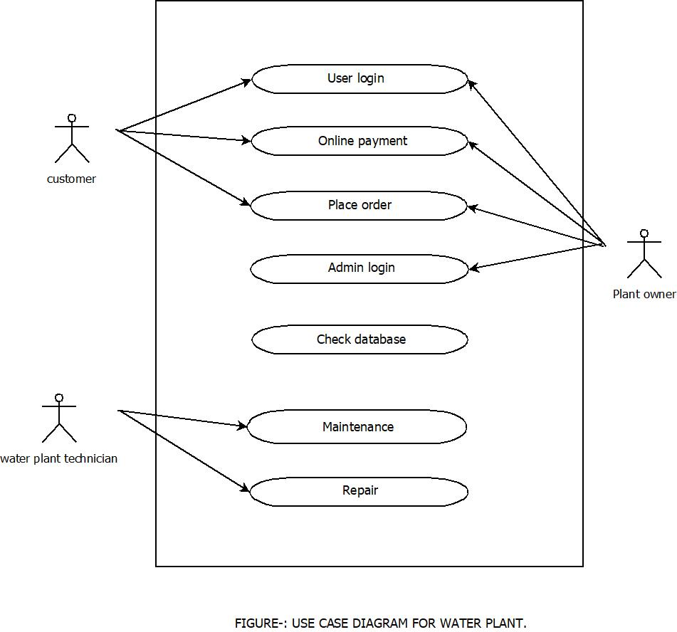

**A use case diagram is a dynamic or behavior diagram in**[**UML**](https://www.smartdraw.com/uml-diagram/)**. Use case diagrams model the functionality of a system using actors and use cases. Use cases are a set of actions, services, and functions that the system needs to perform. In this context, a "system" is something being developed or operated, such as a web site. The "actors" are people or entities operating under defined roles within the system.**

**Use case diagrams are valuable for visualizing the functional requirements of a system that will translate into design choices and development priorities.**

**They also help identify any internal or external factors that may influence the system and should be taken into consideration.**

**They provide a good high level analysis from outside the system. Use case diagrams specify how the system interacts with actors without worrying about the details of how that functionality is implemented.**

* Basic Use Case Diagram Symbols and Notations

**System**  
Draw your system's boundaries using a rectangle that contains use cases. Place actors outside the system's boundaries.

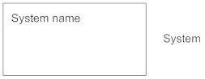

**Use Case**  
Draw use cases using ovals. Label the ovals with verbs that represent the system's functions.

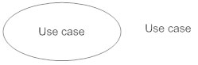

**Actors**  
Actors are the users of a system. When one system is the actor of another system, label the actor system with the actor stereotype.

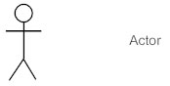

**Relationships**  
Illustrate relationships between an actor and a use case with a simple line. For relationships among use cases, use arrows labeled either "uses" or "extends." A "uses" relationship indicates that one use case is needed by another in order to perform a task. An "extends" relationship indicates alternative options under a certain use case.

* **Activity diagram**

Activity diagrams are graphical representations of [workflows](https://en.wikipedia.org/wiki/Workflow) of stepwise activities and actions[[1]](https://en.wikipedia.org/wiki/Activity_diagram#cite_note-1) with support for choice, iteration and concurrency. In the [Unified Modeling Language](https://en.wikipedia.org/wiki/Unified_Modeling_Language), activity diagrams are intended to model both computational and organizational processes (i.e., workflows), as well as the data flows intersecting with the related activities.[[2]](https://en.wikipedia.org/wiki/Activity_diagram#cite_note-2)[[3]](https://en.wikipedia.org/wiki/Activity_diagram#cite_note-3) Although activity diagrams primarily show the overall flow of control, they can also include elements showing the flow of data between activities through one or more data stores.

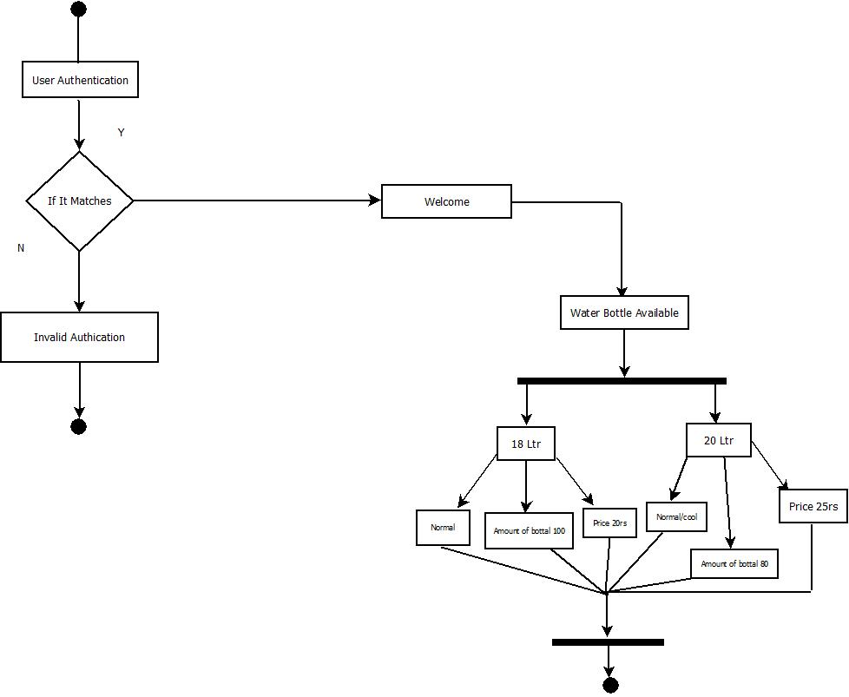

## Basic Activity Diagram Notations and Symbols

##### Initial State or Start Point

A small filled circle followed by an arrow represents the initial action state or the start point for any activity diagram. For activity diagram using swimlanes, make sure the start point is placed in the top left corner of the first column.

Start point symbol - Activity diagram

##### Activity or Action State

An action state represents the non-interruptible action of objects. You can draw an action state in SmartDraw using a rectangle with rounded corners.

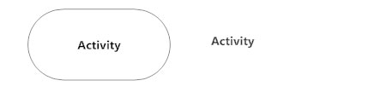

##### Action Flow

Action flows, also called edges and paths, illustrate the transitions from one action state to another. They are usually drawn with an arrowed line.

Action flow - Activity diagram

##### Object Flow

Object flow refers to the creation and modification of objects by activities. An object flow arrow from an action to an object means that the action creates or influences the object. An object flow arrow from an object to an action indicates that the action state uses the object.

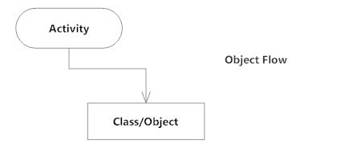

##### Decisions and Branching

A diamond represents a decision with alternate paths. When an activity requires a decision prior to moving on to the next activity, add a diamond between the two activities. The outgoing alternates should be labeled with a condition or guard expression. You can also label one of the paths "else."

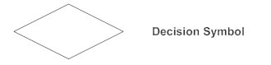

##### Guards

In UML, guards are a statement written next to a decision diamond that must be true before moving next to the next activity. These are not essential, but are useful when a specific answer, such as "Yes, three labels are printed," is needed before moving forward.

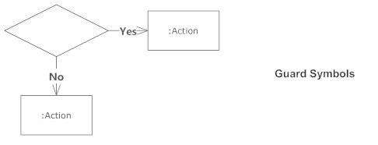

* **DFD Diagram**

A data flow diagram (DFD) illustrates how data is processed by a system in terms of inputs and outputs. As its name indicates its focus is on the flow of information, where data comes from, where it goes and how it gets stored.

**ss.** Dataflows are pipelines through which packets of information flow. Label the arrows with the

name of the data that moves through it.

* Basic DFD Diagram Notations and Symbols

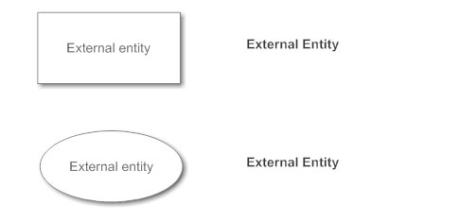

**Process Notations.** A process transforms incoming data flow into outgoing data flow.

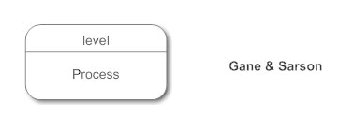

**Datastore Notations.** Datastores are repositories of data in the system. They are sometimes also referred to as files.

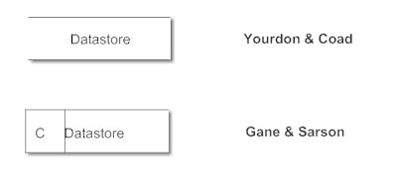

**Dataflow Notations.** Dataflows are pipelines through which packets of information flow. Label the arrows with the name of the data that moves through it.

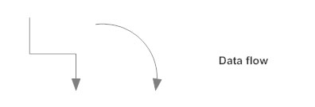

**DFD Level 0**

A level 0 data flow diagram (DFD), also known as a context diagram, shows a data system as a whole and emphasizes the way it interacts with external entities. This DFD level 0 example shows how such a system might function within a typical retail business. To edit this DFD level 0 template, simply register a free Lucidchart account, then log in to start adding your own text, images, and more.

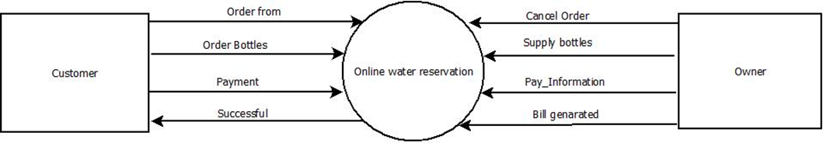

**DFD Level 1**

as detailed as a level 2 DFD. It breaks down the main processes into subprocesses that can then be analyzed and improved on a more intimate level. You can edit this DFD level 1 template with a free Lucidchart account. After signing up, you can change the shape placement, text content, and more.

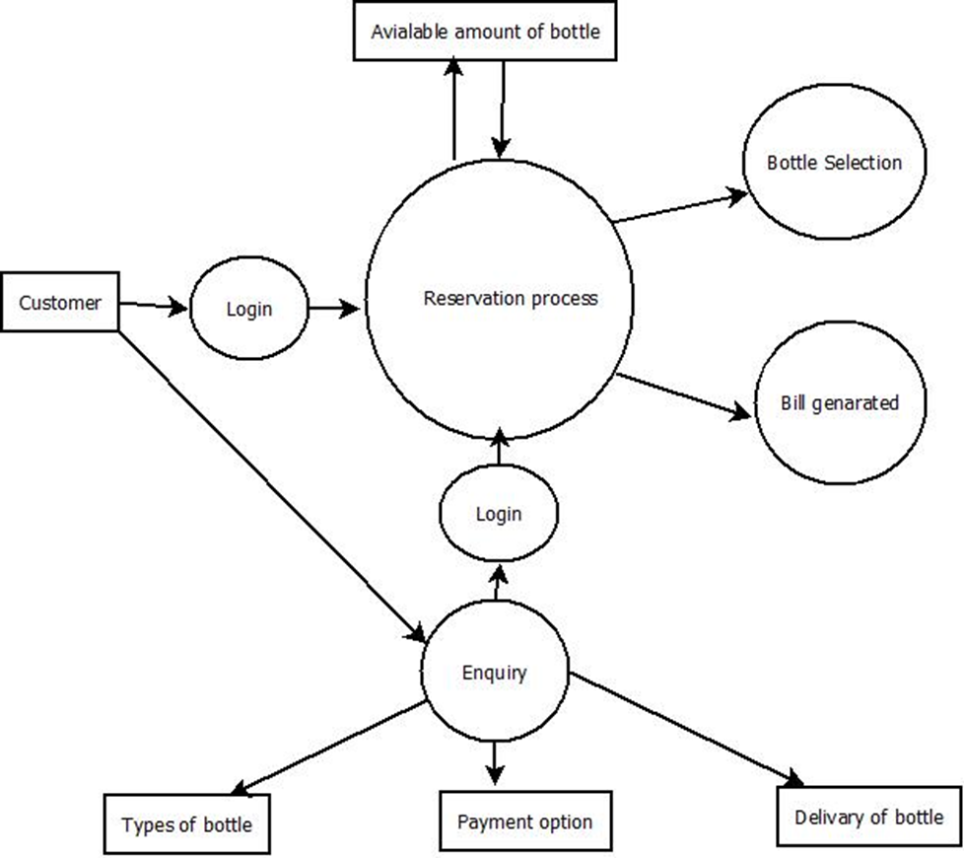

* **Conclusion**

**The case study assignment gives a good knowledge to the student in the college because when the student starts on the case study, they have full concentration on the work. They would have good character in their life. By doing some of the case studies they would gain a lot of knowledge. They would know how to present the paper. It would be very useful for the future purpose. When they assign the task to them, they would easily solve the case and bring it on time.We have successfully preaped a case study for above project.**

* **Reference**

1. https:://www.techopedia.com
2. https:://www.projectmanager.com

### **[3)Data Flow Diagram - Everything You Need to Know About DFD](https://www.smartdraw.com/data-flow-diagram/)**

### **[4)Use case diagram - Wikipedia](https://en.wikipedia.org/wiki/Use_case_diagram)**

[en.wikipedia.org › wiki › Use_case_diagram](https://en.wikipedia.org/wiki/Use_case_diagram)

### **[5)Activity Diagram - Activity Diagram Symbols, Examples, and ...](http://5)Activity Diagram - Activity Diagram Symbols, Examples, and ...www.smartdraw.com › activity-diagram)**

[www.smartdraw.com › activity-diagram](http://5)Activity Diagram - Activity Diagram Symbols, Examples, and ...www.smartdraw.com › activity-diagram)



**MAHARASHTRA STATE**

**BOARD OF TECHNICAL EDUCATION**

**Certificate**

This is to certify that **Mr.Harsh Santosh Zanwar** Roll No **945** of **4th** Semester of Diploma in **INFORMATION TECTNOLOGY** of Institute, **GOVERNMENT POLYTECHNIC** has completed the **Micro Project satisfactorily** in Subject -**SEN(22413)** for the academic year 2019- 2020 as prescribed in the curriculum.

Place: **Nanded**

Date: ………………………

**Subject Teacher Head of the Department Principal**

**K.P.POPLE Mr.S.N.Dhole Dr.G.V.Garje**



**MAHARASHTRA STATE**

**BOARD OF TECHNICAL EDUCATION**

**Certificate**

This is to certify that **Mr.Vishal vaijenath nilwarn**  Roll no **953** of **4th** Semester of Diploma in **INFORMATION TECTNOLOGY** of Institute, GOVERNMENT POLYTECHNIC has completed the **Micro Project satisfactorily** in Subject -**SEN(22413)** for the academic year 2019- 2020 as prescribed in the curriculum.

Place: **Nanded**

Date: ………………………

**Subject Teacher Head of the Department Principal**

**K.P.POPLE Mr.S.N.Dhole Dr.G.V.Garje**



**MAHARASHTRA STATE**

**BOARD OF TECHNICAL EDUCATION**

**Certificate**

This is to certify that **Mr.Md Hifaz Khan** Roll no **949** of **4th** Semester of Diploma in **INFORMATION TECTNOLOGY** of Institute, GOVERNMENT POLYTECHNIC has completed the **Micro Project satisfactorily** in Subject -**SEN (22412)** for the academic year 2019- 2020 as prescribed in the curriculum.

Place: **Nanded**

Date: ………………………

**Subject Teacher Head of the Department Principal**

**K.P.POPLE Mr.S.N.Dhole Dr.G.V.Garje**



**MAHARASHTRA STATE**

**BOARD OF TECHNICAL EDUCATION**

**Certificate**

This is to certify that **Mr.Amaan Khan Pathan** Roll no **948** of **4th** Semester of Diploma in **INFORMATION TECTNOLOGY** of Institute, GOVERNMENT POLYTECHNIC has completed the **Micro Project satisfactorily** in Subject -**SEN (22413)** for the academic year 2019- 2020 as prescribed in the curriculum.

Place: **Nanded**

Date: ………………………

**Subject Teacher Head of the Department Principal**

**K.P.POPLE Mr.S.N.Dhole Dr.G.V.Garje**